Contents

Cryotherapy generic overview 3

Types of Cryotherapy 3

The types are:- 4

Ice 4

Ice Gels 5

Aerosol Cold Spray Cans 6

Cold and Compression units 7

Cryo Fan (nitrogen) 9

CryoPod (single cryo chamber) 9

CryoChambers (whole body chambers) 9

CO2 cold spray devices 10

Partial Body Cryotherapy (PBC) 11

Vets/Racing Animal Trainers 11

Beauty & Clinical - Paul/Ranj 12

Physios/Performance/recovery - Dave/Paul 12

Nitrogen Handling – Paul 12

C02 & Handling - Ranj 12

General Health & safety – Dave/Paul/Ranj 13

Contraindications – Paul 13

Definition 14

History 14

The notion of “thermal shock” 15

The effects of Cryotherapy 16

Analgesia 16

Anti-inflammation 16

Neurological effects 16

Vasomotor reactions 17

Methods 18

Ice (conduction) 18

Cryogel (conduction) 18

Airflow (Conduction) 19

GameReady (Conduction) 19

Gasiform cryotherapy (sublimation) 19

General applications 20

Sports medicine – PRICE concept 20

Indications and Contraindications 21

**CryoSafe Manual**

Cryotherapy generic overview (Dave)

Cryotherapy or using cold. However, the concept is not new, but dates as far back as 2500 BC, when ancient Greeks and Egyptians used this form of localized cold therapy to alleviate pain and inflammation.

According to Joanna Radin, a medical historian at Yale,

The use of cold for therapy evolved in three stages after the ice age.

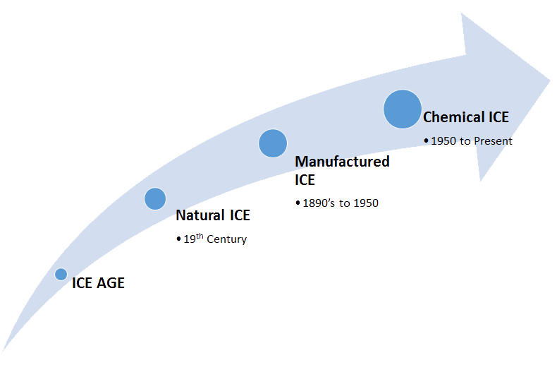

Physicians have long made use of the medicinal powers of cooling. Hippocrates wrote that cold water is to be applied “when there is a haemorrhage, or when it is expected.” During the French Army’s ghastly retreat from Moscow in 1812, Napoleon’s surgeon in chief, Dominique Jean Larrey, used ice and snow to numb soldiers before field amputations.

Physicians used ice and cold water to numb soldiers before amputations

The technique was further developed in the 20th century by Japanese, Polish and French doctors, who were searching for ways to ease their patients’ discomfort increase recovery.

Cryotherapy is the local or general use of low temperatures in medical therapy. Cryotherapy is used to treat a variety of benign and malignant tissue damage, medically called lesions. The term "cryotherapy" comes from the Greek cryo (κρύο) meaning cold, and therapy (θεραπεία) meaning cure. Cryotherapy termology has been used as early as the seventeenth century.

# Types of Cryotherapy

With modern times and technologies there are now many different types and ways using cryotherapy out there in the market. They are all trying to achieve the same goal which is to relieve pain and inflammation as well as increase the rate of recovery. Some are standalone as others are adjunctive therapy. Some claim to have do more that pain relief and claim to increase weight loss and can be used for ascetic’s purposes.

Ice is easy to obtain in the form of ice cubes, but although it has advantages which are formally

acknowledged and non-negligible, its use is not very practical and imposes constraints. Indeed,

in order to be efficient, the vessel containing ice cubes has to be big enough to cover the area

to be treated, and this requires more ice than an ordinary fridge can produce. It is therefore

necessary for a clinic or treatment centre to purchase an ice cube machine, which is rather

expensive. Furthermore, the ice vessels are only waterproof if they don’t leak and the problem of the humidification of the tissues to be treated is constant.

Some laboratories studied the problem and produced the second generation: Cryogel.

It is a gel contained in a watertight plastic bag that can be cooled in the fridge or the freezer.

The use of Cryogel is much easier than that of ice and has the advantage of eliminating the

problems of humidification. However:

- 2 hours in the fridge bring it down to -3ˇC

- 3 to 4 hours in the freezer bring it down to -14ˇC. It is then possible that it provokes burns

because there is, as of yet, no method to measure the skin temperature.

After these solid cryotherapy treatments, gas cryotherapy appeared: the Japanese Professor

Yamauchi at the end of the 70s, the German Professor Fricke in 1982, and then the French in

1986, developed this therapeutic concept. The interest that the medical establishment granted

these techniques resulted in the first international Cryotherapy Symposium in Madrid in 1990.

Cold Compression units also started to be developed to provide better cold therapy and from this chemical cold therapy was created from advances in technology. Today cryotherapy is still in its infancy and further research is needed even though the evidence out there does generally support these new technology as being very effective for many uses.

## The types are:-

### Ice

Ice therapy is a treatment of cold temperatures to an injured area of the body. An ice pack is placed over an injured area and is intended to absorb heat of a closed traumatic or edematous injury by using conduction to transfer thermal energy. The physiologic effects of cold application include immediate vasoconstriction with reflexive vasodilation, decreased local metabolism and enzymatic activity, and decreased oxygen demand. Cold decreases muscle spindle fiber activity and slows nerve conduction velocity, therefore it is often used to decrease spasticity and muscle guarding. It is commonly used to alleviate the pain of minor injuries, as well as decrease muscle soreness. The use of ice packs in treatment decreases the blood flow most rapidly at the beginning of the cooling period, this occurs as a result of vasoconstriction, the initial reflex sympathetic activity. As stated previously, ice is a very popular modality for treatment in injuries and muscle repair following any activity, however the application of cold prior to activity is also an option, and is often used in sports medicine.

Suitable for

Adults and children aged 2 years and above.

How to use Ice

Ice can be used directly on the skin but caution must be applied leaving it on one spot for more than 10 minutes unless it’s wrapped in a light cloth or plastic bag.

Ice is not commonly used prior to rehabilitation or performance because of its known adverse effects to performance such as decreased myotatic reflex and force production, as well as a decrease in balance immediately following ice pack therapy for 20 minutes. However, if ice pack therapy is applied for less than 10 minutes, performance can occur without detrimental effects. The physiological effects that the body goes through after cold therapy application include initial vasoconstriction, shunting all blood away from the body part, followed by vasodilation, as blood flows back to the affected area in attempt to re-warm. If the ice bag therapy is removed at this time, sportsmen are sent back to training or competition directly with no decrease in performance.

Ice packs placed on the skin takes the skin temperature to around 6 – 10 C and should be not exceed 20 minutes otherwise it can cause necrosis.

Do not use

Do not use on open wounds or irritated skin

More than 20 minutes application it will cause necrosis

Ingredients

Frozen water

Limitations

Limited use

Time restriction

Atmosphere conditions and climate will make an impact to its therapeutic properties

### Ice Gels

An ice gel pack is a portable plastic sac filled with refrigerant gel or liquid. For use the contents are frozen in a freezer. Both ice and other non-toxic refrigerants (mostly water) can absorb a considerable amount of heat before they warm above 0 °C, due to the high latent heat of fusion of water. These packs are commonly used to keep food cool in portable coolers, or as a cold compress to alleviate the pain of minor injuries; or in insulated shipping cylinders to keep products cool during transport.

Gel packs have been made with diethylene glycol and ethylene glycol both of which can cause illness if ingested in large amounts

### Aerosol Cold Spray Cans

Aerosol Cold Spray works rapidly like ice, delivering an instant burst of cooling pain relief. Fast acting and effective, it helps relieve painful sprains, strains, muscles and the pain associated with arthritis and backache.

Cooling therapy for muscles and joints is well established and recommended by sports physiotherapists and health professionals. Can be used during or immediately after exercise.

Suitable for

Adults and children aged 6 years and above.

How to use Aerosol Cold Spray:

Shake can before use. Always try on a small area first.

Hold 15cm from affected area and spray in 2 - 3 short bursts.

Wash hands after use.

Repeat up to 3 times per day.

If symptoms persist, seek medical advice.

Hazards and Cautions

For external use only. Do not inhale.

Do not use:

On broken or irritated skin or with other skin products on the same area

If allergic to any of the ingredients .

On or near the eyes or other sensitive areas

On children under 6 years

If you are diabetic, have poor circulation or a skin condition, are pregnant or breastfeeding, consult your doctor before use.

Ingredients

Pentane, butane 75, denatured ethanol, levomenthol

An aerosol burn is an injury to the skin caused by the pressurized gas within an aerosol spray cooling quickly, with the sudden drop in temperature sufficient to cause frostbite to the applied area. Medical studies have noted an increase of this practice, known as "frosting", in pediatric and teenage patients.

Adiabatic expansion causes the gas (with a low boiling temperature) to rapidly cool on exit from the aerosol applier. According to controlled laboratory experiments, the gas from a typical deodorant spray can reduce skin temperature by up to sixty degrees Celsius.

The form of injury is freezing of the skin, a type of frostbite. It is highly advised for those who suffer from frostbite to seek medical attention.

In rare cases aerosol-induced burns can be severe enough to necessitate skin grafting.

### Cold and Compression units

Cold Compression Therapy combines two of the principles of R.I.C.E. (Rest, Ice, Compression, Elevation) to reduce pain and swelling from a sports or activity injury to soft tissues and recommended by orthopedic surgeons following surgery. The therapy is especially useful for sprains, strains, pulled muscles and pulled ligaments.

Cold Compression is a combination of cryotherapy and static compression, commonly used for the treatment of pain and inflammation after acute injury or surgical procedures.

Static compression is often used in conjunction with cryotherapy for the care of acute injuries. To date, the primary reason for using compression is to increase external pressure on the tissue to prevent edema formation (swelling). This occurs by hindering fluid loss from the vessels in the injured area, making it more difficult for fluids to accumulate. Ice with compression is significantly colder than ice alone due to improved skin contact and increased tissue density caused by extended static compression. Tissue reaches its lowest temperature faster and the tissue maintains its cool even after treatment ends.

Continuous Cold Therapy Devices (also called ice machines) which circulate ice water through a pad are currently the subject of class action lawsuits for skin and tissue damage caused by excessive cooling or icing time and lack of temperature control. Reported injuries range from frostbite to severe tissue damage resulting in amputation.

Studies have shown that the body activates the hunting response after only 10 minutes of cryotherapy, at temperatures less than 49F (9.5C). The hunting response is a cycle of vasoconstriction (decreased blood flow), then vasodilation (increased blood flow) that increases the delivery of oxygen and nutrient rich blood to the tissue. Increased blood flow can slow cell death, limit tissue damage and aid in the removal of cellular debris and waste products. Under normal circumstances the hunting response would be essential to tissue health but only serves to increase pain, inflammation and cell death as excess blood is forced into the area.

Cold compression wraps using either re-freezable ice or gel are a much safer product, as such products do not exceed the cooling or icing time recommended by the established medical community.

Many of the ice wraps available use adjustable elastic straps to aid in compression over the injured areas. More advanced single-use wraps have guidelines to indicate how the bandage should be applied in order to achieve optimum compression required for an acute injury.

Most ice wraps that use ice, have a built-in protective layer, so ice is not applied directly to the skin, which can result in a burn to the area sometimes known as a "cryoburn".

Suitable for:

Adults and children aged 16 years and above.

How to use Cold Compression units:

Make sure you obtain the right equipment for the treatment. There are many companies but are all basically the same. You put the cuff around the injury and connect the device. The unit then pumps the cold water around the cuff and applies compression for a various times. Minimum duration is 30 mins

Do not use:

Compression Therapy (pneumatic compression) or any compression therapy device should not be used in patients:

·Who are in the acute stages of inflammatory phlebitis in the affected region?

·Who have any history or risk factors for deep vein thrombosis or pulmonary embolus (including prolonged bed rest) in the affected region (to be treated with this therapy)

·Who have significant arteriosclerosis or other vascular ischemic disease in the affected region

·Who have a condition in which increased venous or lymphatic return is not desired in the affected extremity (eg, carcinoma)

·Who have decompensated hypertonia in the affected region?

·Who have significant vascular impairment in the affected region (eg, from prior frostbite, diabetes, arteriosclerosis or ischemia)

·Who have acute paroxysmal cold hemoglobinuria or cryoglobulinemia

It is always recommended that you consult with your Physiotherapist, Rehabilitation Therapist or GP/ Surgeon before starting any new injury treatment regime, especially if you have recently undergone surgery. The information contained in this website is not intended as a substitute for professional medical advice. Always seek the advice of your GP or other qualified healthcare provider with any questions you may have regarding contraindications for cryotherapy and vasopneumatic compression

Ingredients:

Ice water and electronically generated pressure

### Cryo Fan (nitrogen)

Was developed by american physician Dr Kuehne, and uses pressurized liquid nitrogen vapors (-130º) which are applied to the face and neck to stimulate skin tissue and in cosequence the production of collagen and decrease pore size. The skin becomes tighter, more toned, and blood circulation is improved. Over time, skin becomes more elastic due to the increase in collagen. Treatments are followed by the application of Beauty O'zone Regenerating Serum.

Suitable for:

How to use Cold Cryofan units:

Do not use:

Ingredients:

### CryoPod (single cryo chamber)

Suitable for:

How to use CryoPod units:

Do not use:

Ingredients:

### CryoChambers (whole body chambers)

Whole body cryotherapy (WBC) is an alternative to cold water immersion or ice packs. This treatment involves exposing individuals to extremely cold dry air (below −100 °C) for two to four minutes. To achieve the subzero temperatures required for WBC, two methods are typically used: liquid nitrogen and refrigerated cold air. During these exposures, individuals wear minimal clothing, which usually consists of shorts for males and shorts and a crop top for females. Gloves, a woollen headband covering the ears, and a nose and mouth mask, in addition to dry shoes and socks, are commonly worn to reduce the risk of cold-related injury. The first WBC chamber was built in Japan in the late 1970s, but WBC was not introduced to Europe until the 1980s, and has only been used in the USA and Australia in the past decade.

WBC was initially intended for use in a clinical setting to treat patients with conditions such as multiple sclerosis and rheumatoid arthritis, and although WBC is provided in over 50 European hospitals and medical clinics, it has now been implemented in many spas, and athletic training facilities as well; elite athletes have recently reported using the treatment to alleviate delayed onset muscle soreness (DOMS) after exercise. Recently, recreational athletes have started to emulate elite athletes in using these treatments after exercise. Reductions in muscle and skin tissue temperature after WBC exposure may stimulate cutaneous receptors and excite the sympathetic adrenergic fibres, causing constriction of local arterioles and venules. Consequently, WBC may be effective in relieving soreness, or muscle pain, through reduced muscle metabolism, skin microcirculation, receptor sensitivity and nerve conduction velocity. Interestingly, a paradoxical increase in rectal temperature, followed by a slight decline, has been reported following exposure to the treatment. There is also a body of evidence to suggest that WBC stimulates the autonomic nervous system (ANS), with a predominance of parasympathetic tone activation, after exposure.

Suitable for:

How to use CO2 units:

Do not use:

Ingredients:

### CO2 cold spray devices

CO2 is Carbon Dioxide in a liquid form under pressure. These device use extreme cold and high pressure to form a sublimation process of Liquid, Gas and Solid in a very short time.

During the procedure the patient can be standing, seated or lying down. It’s used as a local CryoStimulation and the only one that applies pressure of unto 50 bar with extreme cold of -78C. The application is a short time of 30 seconds of a particular parts of the body (muscles, tendons, joints or trigger points) the body responds by driving increased levels of blood flow to the treatment area. Which in effect heats up the area and increases metabolic processes to support faster healing and rehabilitation along with auxiliary benefits.

Once the skin temperatures reaches between 4-5C the body receptors under the skin reaches thermic shock and reacts four key physiological effects:

Analgesic effect

Anti-inflammatory responses

Vasomotor effect

Myo-relaxant effect

Theie are 2 types of C02 gas that can be used:

Medical Grade – Purity is 99.9%

Industrial Grade – Purity is approx. 90%

Suitable for:

Adults and children aged 2 years and above.

Pregnant woman first 2 trimesters

How to use Cold Compression units:

They are numerous CO2 devices in the market and they all have different safety measures to avoid tissue burn. It’s important to keep a distance of around 8-10 cm until dry ice is form on the skin and do not keep in a fix place for too long. A sweeping motion around the injury is the best action.

Do not use:

Allergy to Cold

Extreme cardiovascular conditions

Ingredients:

Liquid CO2 under pressure.

# Partial Body Cryotherapy (PBC)

PBC devices or 'cryosaunas' are cylindrical chambers, typically having an aperture at the top, with the patient's head remaining outside and not subjected to the cold stimulus. These devices are commonly used throughout United States and are erroneously referred to as offering "Whole Body Cryotherapy". A further key difference between PBC and WBC is the usage of injection of evaporated liquid nitrogen into the PBC chamber with the potential adverse effects as listed below.

Adverse effects

Systematic reviews of whole body cryotherapy have repeatedly called for research studies to implement active surveillance of adverse events, which are suspected of being underreported. If the cold temperatures are produced by evaporating liquid nitrogen, there is the risk of inert gas asphyxiation as well as frostbite.

# Vets/Racing Animal Trainers

Cold Therapy is very effective for racing animals and pets and many methods can be applied apart from whole body cryotherapy and cryopods due to the potential stress and freezing of the animal.

These is not a specific WBC or Cryopod designed for animals as yet.

From case studies carried out its obvious that cryotherapy from ice to nitrogen and CO2 is very effective. Each application is as its own features and benefits that can suit a wide range of conditions.

List all conditions and protocols - Ranj

# Beauty & Clinical - Paul/Ranj

# Physios/Performance/recovery - Dave/Paul

# Nitrogen Handling – Paul

Liquid nitrogen is a cryogenic liquid. When insulated in proper cylinders such as Dewar flasks, it can be transported without much evaporative loss.

Like dry ice, the main use of liquid nitrogen is as a refrigerant. Among other things, it is used in the cryopreservation of blood, reproductive cells (sperm and egg), and other biological samples and materials. It is used in the clinical setting in cryotherapy to remove cysts and warts on the skin. It is used in cold traps for certain laboratory equipment and to cool infrared detectors or X-ray detectors. It has also been used to cool central processing units and other devices in computers that are overclocked, and that produce more heat than during normal operation. Other uses include freeze-grinding and machining materials that are soft or rubbery at room temperature, shrink-fitting and assembling engineering components, and more generally to attain very low temperatures whenever necessary (around −200 °C). Because of its low cost, liquid nitrogen is also often used when such low temperatures are not strictly necessary, such as refrigeration of food, freeze-branding livestock, freezing pipes to halt flow when valves are not present, and consolidating unstable soil by freezing whenever excavation is going on underneath. It is also increasingly being used for cryotherapy for cryochambers, cryopods and cryofans.

# C02 & Handling - Ranj

Liquid carbon dioxide is recovered from a variety of sources sources such as ammonia and hydrogen plants, purified and liquefied.

It is delivered to our customers in liquid form, into onsite storage, for use in high-volume customer applications.

Carbon dioxide is stored as a liquid in a specialised vessels which can provide several days' supply and be used on demand as either a liquid or gas.

Features

Refrigerated liquefied gas

Boiling point -78.5o C

Gas/vapour heavier than air

Odourless and colourless

Stable under normal circumstances

Suck back of water into the cylinder must be prevented. Do not allow backfeed into the cylinder. Use only properly specified equipment which is suitable for this product, its supply pressure and temperature. Contact your gas supplier if in doubt. Check regularly tightness of the plant. Refer to supplier's handling instructions. The

substance must be handled in accordance with good industrial hygiene and safety procedures. Purge system with dry inert gas before gas is introduced and when system is placed out of service. Do not smoke while handling product. Only experienced and properly instructed persons should handle gases under pressure. Protect cylinders from physical damage; do not

drag, roll, slide or drop. Never use direct flame or electrical heating devices to raise the pressure of a cylinder. Do not remove or deface labels provided by the supplier for the identification of the cylinder contents. When moving cylinders, even for short distances, use a cart (trolley, hand truck, etc.) designed to transport cylinders.

Leave valve protection caps in place until the cylinder has been secured against either a wall or bench or placed in a cylinder stand and is ready for use. Ensure the complete gas system has been (or is regularly) checked for leaks before use. If user experiences any difficulty operating cylinder valve discontinue use and contact

supplier. Close cylinder valve after each use and when empty, even if still connected to equipment. Never attempt to repair or modify cylinder valves or safety relief devices. Damaged valves should be reported immediately to the supplier. Replace valve outlet caps or plugs and cylinder caps where supplied as soon as cylinder is disconnected from equipment. Keep cylinder valve

outlets clean and free from contaminates particularly oil and water. Never attempt to transfer gases from one cylinder/cylinder to another. Avoid suck back of water, acid and alkalis.

# General Health & safety – Dave/Paul/Ranj

# Contraindications – Paul

Why the Pros Prefer Localized Cryotherapy

Although whole-body cryotherapy has undisputed benefits, localized cryotherapy presents some distinct advantages if you are recovering from surgery or an injury. Some of the factors the pros consider when deciding between whole-body and localized therapy include:

• Safety - Localized cryotherapy presents minimal risk to skin or other tissues. Because you are able to control the temperature of therapeutic cold and the amount of time it is applied, there is limited to no risk of frostbite or any other type of skin damage.  
• Comfort - Many patients are simply not comfortable standing in a freezing chamber in their bathing suit. The experience of a whole-body cryotherapy chamber, although invigorating, is not pleasant for everybody. With localized cryotherapy, the patient can sit comfortably while the machine does all the work.   
• Efficacy - Many health benefits have been reported for patients who undergo whole-body cryotherapy, but when it comes to the treatment of injuries and post-surgical recovery, localized cryotherapy is more effective because of the addition of active compression. Therapeutic cold is applied for longer and is able to penetrate deeper into the damaged tissues to help stimulate healing and repair.  
• Cost - Localized cryotherapy is much less expensive to administer than the whole-body alternative. Many insurance companies also do not cover whole-body cryotherapy, so patients have to pay for the entire expense.   
• Practical application - The application of localized cryotherapy requires only a compact portable system and access to ice for the reservoir. A whole-body cryochamber is not portable, takes up much more space in a clinic, and requires the purchase of nitrogen. Practically speaking, localized cryotherapy is much easier to administer. In fact, patients can even rent equipment to use at home during injury recovery.

All patients and healthcare providers have different preferences for recovery from surgery or an injury, but most athletic trainers and physical therapists prefer the portability, convenience, and proven efficacy of a localized cryotherapy system. The addition of active compression makes localized cryotherapy even more effective and helps accelerate healing more quickly than with cold alone.

Cryonic Medical is widely used by doctors and trainers to help patients quickly recover from injuries and surgery. Whether they are trying to help an athlete heal from knee surgery in time to participate in the Olympics or keep a Rugby or Football player at the top of his game without surgical intervention, healthcare professionals choose

# Definition

Cryotherapy is the therapeutically application of cold that can be obtained in various ways(with ice, cold water, damp cloth, methyl chloride, carbon dioxide…).Basically cryotherapy can be divided in three groups “contact”, “airflow” and“ gas”. In cryotherapy by contact, cold is transferred via contact of something cold(ice, snow, cold pack,)on the treated spot where as this direct contact is avoided in the two other groups. With gas (nitrogen,C0 2 …)is blown to cool down the area where as free surrounding air is used to cool down the treatment zone in airflow cryotherapy.

# History

Since time immemorial Cryotherapy has been used in the treatment of traumatology. The use of ice and snow as therapeutically means was already mentioned by Hippocrates (460-377 before J.-C.).

Cryotherapyhasbeenusedveryfrequentlybecauseofitsbeneficialeffects; but in a completely empirical way. This method of treatment, of course, makes the results very in consistent and this is probably the reason why cryotherapy is adulated by some and denounced by others.

The method of application of cryotherapy has gone through several evolutions, of course, butitisespeciallytheincreaseinphysiologicalknowledgethathasallowedustobetter understandtheeffectsandmadeitpossibletobetterdeterminethevariousfieldsof applications and the modes of operation.

The notion of “thermal shock”

In the early seventies various studies proved that, to be really effective in Cryotherapy, attempts to create a “*thermal shock*” had to be carried out.

Thermal shock is a very rapid drop in temperature in a minimum of time.

We must consider that under normal conditions skin temperature is situated in the area of 34-35°C.It’s this temperature that must drop as much as possible in a minimum of time(within certain limits, of course, as we will explain further on)

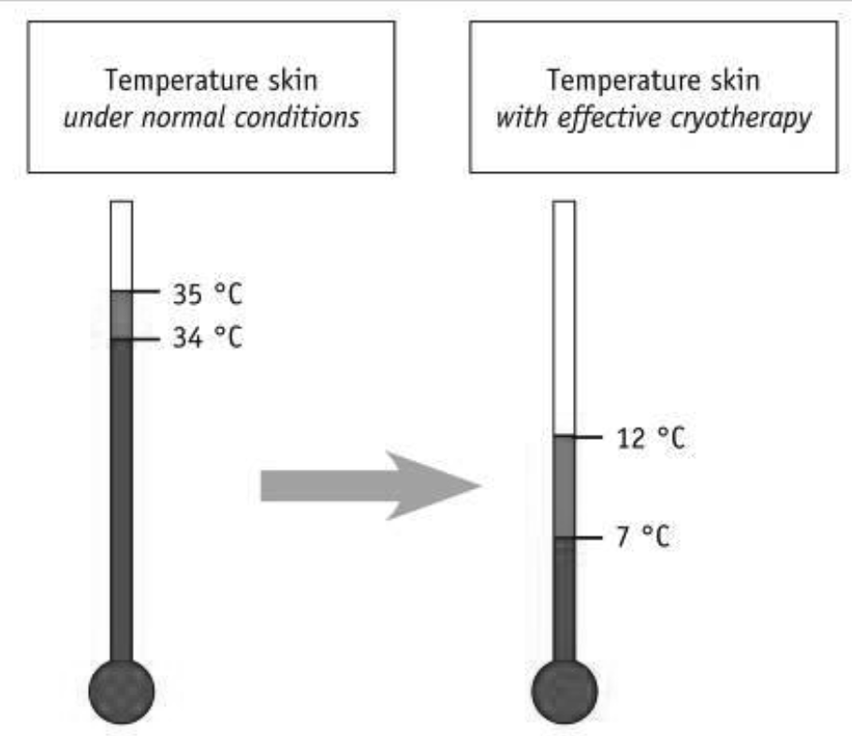



The effects of Cryotherapy

Cryotherapy uses very low skin temperatures and causes in that way four effects.

Analgesia

The maximal effect is reached immediately (within 10 to 15 seconds) during the treatment and it will remain effective, depending on circumstances, from 30 minutes to 3 hours after the treatment has been stopped (the average duration is one hour). You can even reach anaesthesia, depending on the condition, but only on a very small area and for a very short period of time.

When the skin temperature goes below 15°C, cold has the effect of slowing down the conduction of nervous impulses. However one should be aware of the fact that, in vitro, a temperature below10°C could **cause damage** to the nervous system. In vivo, **this limit can be fixed between 5and 7°C**.Thus,thermalshock will consist of lowering the skin temperature from 34-35°C to less than 15°C, but never reaching a skin temperature lower than 4 °C.

Cold will also decrease the irritability of the nociceptors (through depolarisation of cell membranes).

Cold also causes the “GateControl” effect. As a matter of fact a massage with ice or sweeping with the cold airflow will stimulate the fibres and it will consequently provoke an inhibition at the level of the dorsal horn of the spinal cord.

Anti-inflammation The importance of inflammation, of the permeability of the capillaries and of the cellular response is directly linked to the temperature of the tissue.

A fast application of cold causes a decrease in the production of neurotransmitters, which are responsible for the inflammation. This makes it possible to decrease the quantity of the substances that cause pain with 70 to 80%, which results in a less intense inflammatory reaction.

By causing a vasoconstriction (arteriolar and capillary), cold will oppose the vasodilatation of the inflammatory reaction. This vasoconstriction is responsible for a decrease of the drainage of the blood flow, for a diminution of the hydrostatic pressure and thus for are duction of the drainage of liquid. By result the plasma-extravasations, responsible for the volume of the oedema, will be limited.

We should draw attention to the fact that cold does not inhibit the drainage of the liquids, responsible for the repair of the tissues. Cold will only slow down this process. This deceleration is compensated largely by the reduction of the harmful effects of the oedema, which will allow for a much earlier rehabilitation by means of exercising.

Neurological effects

As already mentioned, cold can provoke analgesia provided that the temperature reaches a level below 15°C.

Cold also reduces muscular spasticity.

It has also been observed that the amplitude of the reflex response during the stretching of the muscle, previously cooled, decreases during and after the application of ice. This phenomenon allowed TRAVELL to develop his technique called “Spray and stretch”, a method which gives good results in the case of muscular spasms (contractures).

Vasomotor reactions

The cooling down of the tissue causes a fast arteriolar and capillary vasoconstriction via the reflexes (thermoregulation). It’s a safety mechanism.

In the year 1930 LEWIS described the changes of the blood flow in the skin, when a hand is dipped in water of 10-12°C during a long period. The reaction is the result of an axon reflex. Since then many authors also described these reactions, although not everyone follows these conclusions. Today is assumed that the alternation of vasodilatation and vasoconstriction is caused by a decrease of the affinity of the adrenergic α-receptors. This difference in conclusions can be explained by the difference in circumstances during the experiments.

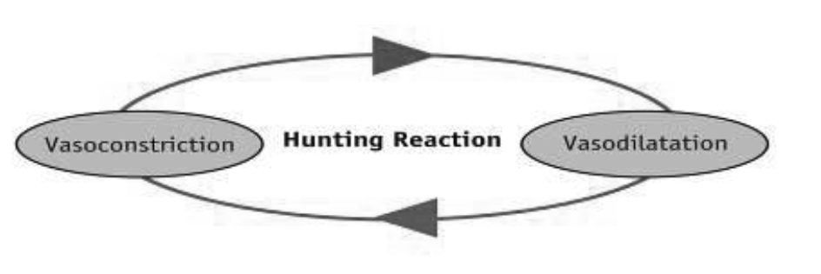

If the application of cold is carried out long enough, it will be followed by a vasodilatation. **This paradoxical vasodilatation corresponds with a protective** **hyperaemia**.If the exposure is prolonged even more, the periods of vasodilatation and those of vasoconstriction will follow after each other. This phenomenon is called the “**Hunting Reaction** or also **Escape**”.In order to observe this phenomenon, the temperature of the tissue must be situated between 4 and 7 °C.

It has also been demonstrated that cold, applied alone, has no direct effect whatsoever on the oedema. In order to have an effect, it must be accompanied by alight compression in an inclined position; the treated area **must absolutely be higher** than the heart. This combination will resolve the oedema faster.

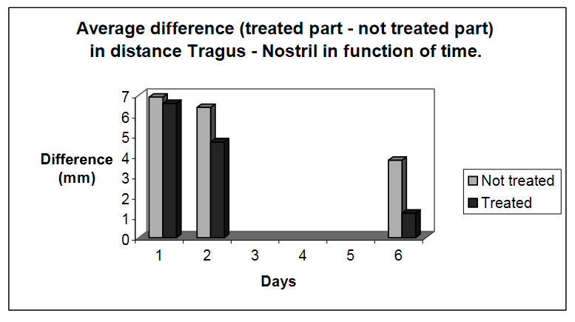

In the diagram you can see that the application of ice (20minutes) Compared to CryoStimulation rapidly reduces the skin temperature down.

Methods

There are two physical principles used to perform Cryotherapy. The sublimation and conduction principles.

## Ice (conduction)

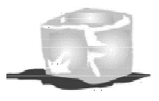

Ice can easily be purchased in the form of ice cubes, but its use is subject to many limitations and is not very practical. Ice can be applied directly (ice massage), or in the form of an “ice pack” (wide sack, containing a mixture of water and finely crushed ice)

Cryogel (conduction)

This is a gel packed in a hermetically sealed packaging, which has to be placed in a Freezer. The use of such a gel is far more practical.

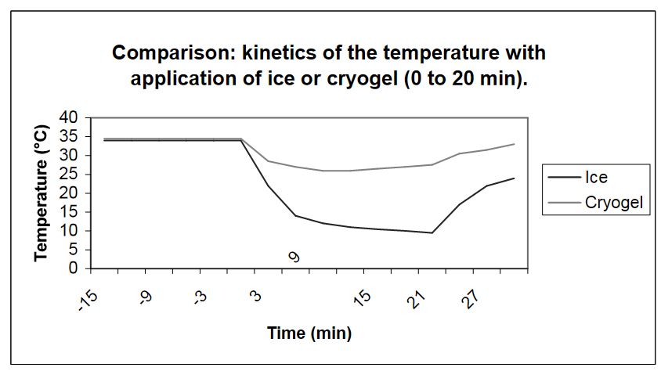

This diagram shows that Cryogel is substantially less effective than ice! Indeed, as a result of its lack of flexibility, it is not possible for the gel to make the completely correct contact with the skin surface, so that there will be a layer of air between the gel and the skin. This layer of air will then play the role of an insulator and it is in that way that the real thermal shock will be prevented from being carried out, so that a great part of the effectiveness of the therapy will be lost.

Airflow (Conduction)

With airflow Cryotherapy **the advantages and the efficiency** Cryotherapy **are on hand**, **excluding its biggest disadvantage**; the use of expensive rechargeable gas cylinders. By extracting free air from the surrounding environment and cooling it (–32ºC, in the device), it generates cold air which is blown on the treated area. The principle is different than the one used with gas the needed temperature to obtain a perfect thermal choc is different. With air, to be efficient the temperature should be at least -30°C

## GameReady (Conduction)

The **Game Ready** System combines **Intermittent Compression** with **Circumferential Cold Therapy** in one fully adjustable, easy-to-use application.RICE (Rest, Ice, Compression, Elevation) has long been used to treat acute and chronic injury and to assist in the recovery and rehabilitation after Orthopaedic surgery.

## Gasiform cryotherapy (sublimation)

At the end of the seventies, a first version of gasiform Cryotherapy was used. The source to create cold was liquid nitrogen, which allowed easily reaching a temperature of-120 °C. However, the problem was the extremely high price delivery can be restricted due to clinic locations.

At the beginning of the nineties a new version was presented, this time liquid CO2 was used as a cryogenic source. This time it provided compression too at 50 Bar. With a gas cylinder, containing medical carbonic acid gas at pressure of 50 bars, cold with a temperatureof-78°C can be produced. The temperature of -78 °C can be endured easily because it’s a perfectly dry gas.

Carbonic acid gas comes out of the apparatus in the form of a microcrystal line carbonic acid ice by means of a vaporization device. The crystals sublimate immediately, which causes a substantial decrease in temperature. It is precisely this factor that is responsible for the thermal shock. The skin temperature reaches a value of 4°C in less than 30 seconds! It is mandatory to turn the gas cylinder upside down, so that the gas (which is lighter) is at the top of the cylinder and the liquid (which is heavier), at the bottom of the cylinder, direct at the connection. This way, it is definitely the liquid phase that will be used. However, **the gas cylinder needs to be replaced regularly**,

# General applications

Cryotherapy can be applied efficiently during the whole acute phase, less during the chronic phase with Conduction modalities Exceptions are tendonitis, which can be treated successfully with cryotherapy also during the chronic phase.

The effectiveness of the cryotherapy is the best during the acute phase, especially during the first 72 hours. Independently from the technology and or the physic principle used, Cryotherapy should always be carried out in two stages:

1. The first stage is the creation of the thermalshock, which means lowering the skin temperature as quick as possible. It is important that this shock appears quickly in order to avoid any adaptation and installation of mechanisms of defence. Ideally, it must appear in less than 3 minutes and if one wants to obtain “neuro-reflexes” reaction, it must appear in less than 1 minute.

2. The second stage is the stabilization of the temperature. It is used for creating and amplifying the “Hunting reaction ”but also cooling the muscular tissue (which is more in-depth and having a certain “mass”)in order to use it like “accumulator” and thus getting a longer effect, even after the end of the treatment. The problem here, will be to stabilize the skin temperature in a way to obtain the effects of the Cryotherapy without having the risks of tissue damage. The ideal temperature is 12° C. Kaasen is the only known device that can regulate and control the temperature with its feature CryoAssist.

However, in order to reduce the swelling, it is advised to elevate the treated area during the application. The treated area must be elevated above the level of the heart. The application of pressure will further enhance the effectiveness of the treatment.

# Sports medicine – PRICE concept

The very well-known and used RICE “concept” can easily be performed and in a very efficient way thanks to the ICE-CT (CryoTherapy).

PRICE stands for: Protection Rest, Ice , Compression and Elevation.

The two modalities in PRICE is ICE and COMPRESSION and the gas CryoStimulation is the only device that does not eliminate any of the modality in PRICE but instead enhances it.

The ICE-CT does all the effect of the ice in an efficient way (cryotherapy with thermal shock) plus the compression with the pressure. Thanks due the ICE-CT, in one operation you perform PRICE.

# Indications and Contraindications

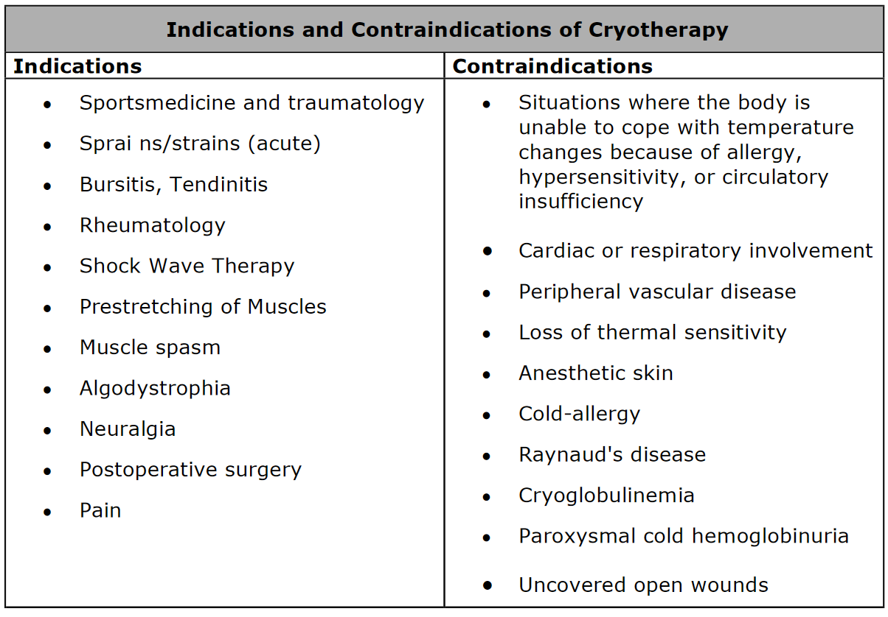

END